**LAB 4**

**Create a program that takes number of rows from the user (assuming that the user enters an odd number less than 9) and prints out a diamond pattern.**

**Output:**

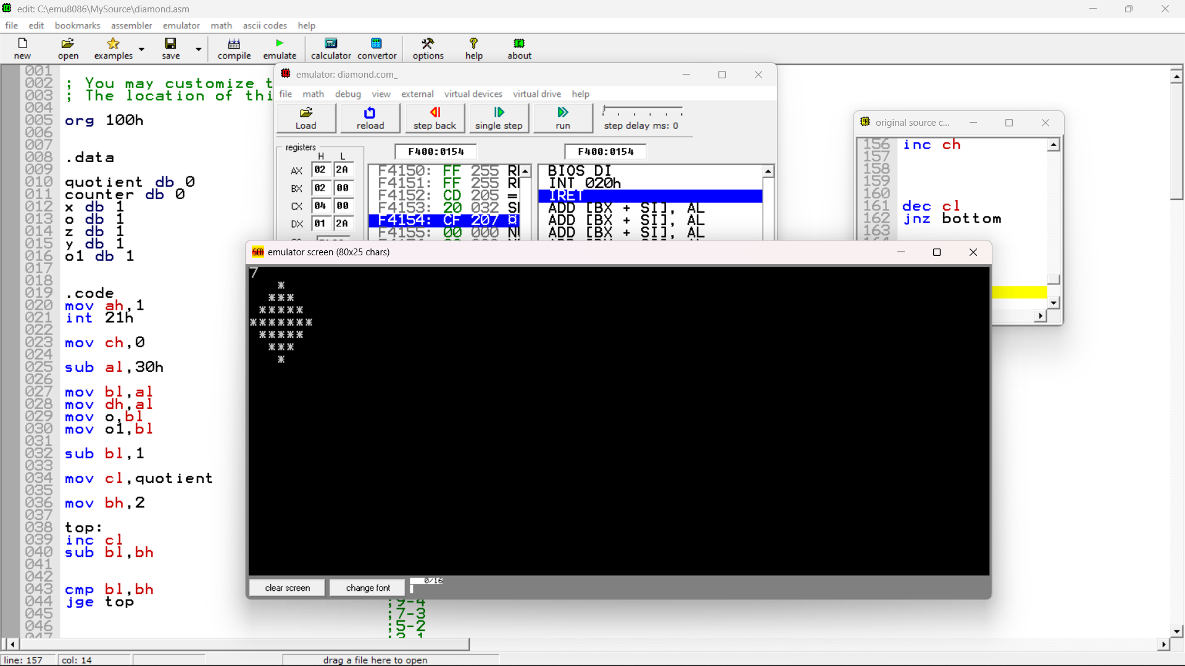

**Program:**

org 100h

.data

quotient db 0

counter db 0

x db 1

o db 1

z db 1

y db 1

o1 db 1

.code

mov ah,1

int 21h

mov ch,0

sub al,30h

mov bl,al

mov dh,al

mov o,bl

mov o1,bl

sub bl,1

mov cl,quotient

mov bh,2

top:

inc cl

sub bl,bh

cmp bl,bh

jge top

mov quotient,cl

mov ch,1

mov z,cl

looop:

mov quotient,cl

mov x,ch

mov ah,2

mov dl,0x0A

int 21h

mov ah,2

mov dl,0x0D

int 21h

top1:

mov ah,2

mov dl,' '

int 21h

dec quotient

jnz top1

jz stars

stars:

inc counter

mov ah,2

mov dl,'*'

int 21h

cmp counter,dh

dec x

jnz stars

inc ch

inc ch

dec cl

jnz looop

mov ah,2

mov dl,0x0A

int 21h

mov ah,2

mov dl,0x0D

int 21h

mid:

inc counter

mov ah,2

mov dl,'*'

int 21h

dec o

jnz mid

mov ch,1

mov cl,z

mov dh,o1

bottom:

dec dh

dec dh

mov ah,2

mov dl,0x0A

int 21h

mov ah,2

mov dl,0x0D

int 21h

mov x,ch

mov y,dh

bottom1:

inc counter

mov ah,2

mov dl,' '

int 21h

dec x

jnz bottom1

stars1:

mov ah,2

mov dl,'*'

int 21h

dec y

jnz stars1

inc ch

dec cl

jnz bottom

ret